Blockchain Based Pharmaceutical Supply Chain Management System

Group Name: Chain Reaction Analysts

Names and Roll Numbers:
Shreya Menon (16010123324)
Shreyans Tatiya (16010123325)
Shubhpreet Kaur (16010123328)
Siddhant Raut (16010123331)

Division: H3
Lab Batch: IDS8 / IDS9

Date of Submission: 15th April 2025
Faculty-in-Charge: Kaustubh Kulkarni

Contents
Abstract 3
Introduction 4
Literature Review 5
Scope for Future Work 7
Conclusion 12
References 13
List of Figures 14
List of Tables 15

Abstract

This paper offers data-based insights into the application of blockchain technology in pharmaceutical supply chain management, specifically its ability to enhance transparency, traceability, and integrity of data. Traditional supply chains are vulnerable to disjointed systems of data, diminished real-time visibility, and risks of counterfeiting.
Based on insights from recent research papers and prototype SilkRoad, designed for the Smart India Hackathon 2024 Finals, this review examines how blockchain can be integrated into supply chains as an immutable, secure, and tamper-evident data base. The article outlines SilkRoad's architecture design in the context of smart contracts for automated verification of compliance, immutable data records for audit trails, and real-time analytics for tracking product movement. Performance metrics such as transaction throughput, latency, and scalability are benchmarked to ascertain the viability of the system in large-scale deployment.
The study also investigates the integration potential with IoT devices for end-to-end data collection, empowering advanced analytics, and predictive intelligence. Results show that blockchain when integrated with data science methodologies gives a viable framework for creating dependable and efficient pharmaceutical supply chains.

Introduction

The pharmaceutical supply chain consists of various components such as medical manufacturers, distributors, regulators, and physicians, making these networks extremely sensitive and complex. There is no margin for error when it comes to the authenticity, safety, and prompt distribution of drugs as it could lead to severe health implications, loss of money, and a legal liability. However, transparency in a traditional supply chain is an issue as it comes with various heterogeneous data sources, and other faults such as drug counterfeiting and data falsification.
Using blockchain technology serves as a solution to all of the aforementioned problems through its decentralized and immutable data ledger for safe share amongst the supply chain. Employing blockchain technology allows the stakeholders to maintain and enhance their trust and efficiency by enabling real-time tracing, automated smart contracts, and proof which is tamper-evident.
When combining analytics with blockchain, there are vast advantages in regard to real-time capture of data, anomaly detection, demand forecasting, and ensuring compliance with regulations. This confluence of technologies can provide insights into some of the most predictive supply chain monitorings such as chokepoints, product recall, and risk management. In modern-day applications, especially post-COVID-19, these systems are being widely used for vaccine distribution control.

Literature Review

Blockchain has emerged as a disruptive technology in various sectors, particularly in supply chain management (SCM), where transparency, traceability, and trust are crucial. In the pharmaceutical domain, supply chain vulnerabilities such as counterfeit drugs, lack of visibility, and inefficient recall mechanisms have made blockchain a promising solution for end-to-end security and control.
1.1 Benefits of Blockchain in SCM
Feature | Traditional SCM | Blockchain SCM
Data Integrity | Prone to manipulation | Immutable
Transparency | Limited visibility | Real-time shared ledger
Traceability | Paper/manual tracking | End-to-end traceability
Operational Efficiency | Manual verification | Automated via smart contracts
Fraud Risk | High | Significantly reduced

Traditional pharmaceutical supply chains are typically siloed and fragmented, leading to frequent breakdowns in visibility and trust. Blockchain addresses these gaps by offering an immutable ledger where each transaction is cryptographically secured and time-stamped. Smart contracts further enhance operational efficiency by enabling automated, trustless execution of predefined actions. These advantages collectively reduce fraud risk, enhance collaboration among stakeholders, and ensure a transparent product lifecycle from raw materials to end consumers.

1.2 Major Supply Chain Challenges & Blockchain Solutions
Challenge | Impact | Blockchain-Based Solution
Counterfeit Drugs | Patient safety risk | Unique hashes & immutable recordkeeping
Fragmented Stakeholder Data | Inefficiencies in coordination | Shared distributed ledger
Manual Verification of Shipments | Time and labor-intensive | Smart contract automation
Limited Forecasting Capabilities | Overstock or understock | On-chain data analytics
Recall Management | Delays, imprecision | Real-time tracking of batches

Blockchain’s decentralized and transparent nature directly addresses critical pharmaceutical SCM challenges. For example, each medicine batch can be uniquely hashed and traced, preventing the infiltration of counterfeit products. Additionally, smart contracts automate shipment validation and trigger alerts for anomalies, ensuring speed and accuracy in recall scenarios.
Recent developments in blockchain technology have motivated a number of innovative solutions in pharmaceutical supply chain management challenges. Agrawal et al. [1] outlined a secure blockchain-based drug recall system with the Hyperledger Composer framework. The model targets both forward and backward supply chain operations with the goal of lowering the cost and duration of drug recalls. The system saves hash values of private information as transactions on the blockchain, keeping it immutable and transparent throughout the process. Real-time deployment proved the effectiveness of the model in enhancing the transparency and traceability of drug flow.
Musamih et al. [2] proposed an Ethereum-based blockchain system to improve drug traceability throughout the healthcare supply chain. Their system combines decentralized off-chain storage through IPFS and smart contracts to implement an end-to-end track and trace system. This system removes intermediaries, ensures data provenance, and offers real-time event tracking through smart contracts. Security and cost analyses demonstrated the system's capability to prevent counterfeit drugs and ensure stakeholder accountability.
Abdallah and Nizamuddin [3] tackled transparency and fraud prevention in online pharmaceutical sales through a suggested blockchain and IoT-based framework. Based on Ethereum smart contracts, their system facilitates automated seller-consumer interaction, tracks drug shipment conditions through IoT sensors, and invokes events upon contract violations like temperature infringement. Their architecture enables consumers to have more visibility with more secure and reliable delivery of pharmaceutical products without the need for third-party intermediaries.
Datta and Namasudra [4] proposed a blockchain-based supply chain management paradigm using Ethereum and IPFS to address scalability and security constraints of conventional systems. With the usage of smart contracts and the Proof-of-Work consensus algorithm, their paradigm achieves data immutability and transaction integrity. Experimental results showed better throughput and communication cost, with cryptographic mechanisms like Schnorr and ECDSA signatures ensuring robust data authenticity and immunity against tampering.

Scope for Future Work

Blockchain technology is also highly promising for improving transparency, traceability, and trust in pharmaceutical supply chains. The potential of data science is still underutilized, and key areas need to be examined for future research.
A significant gap exists in the absence of predictive analytics and machine learning. Most of the current models do not make use of history to forecast demand surges, stockout, or expiration. Techniques like time series, regression, or deep learning would significantly improve inventory management, especially in hospitals and retail.
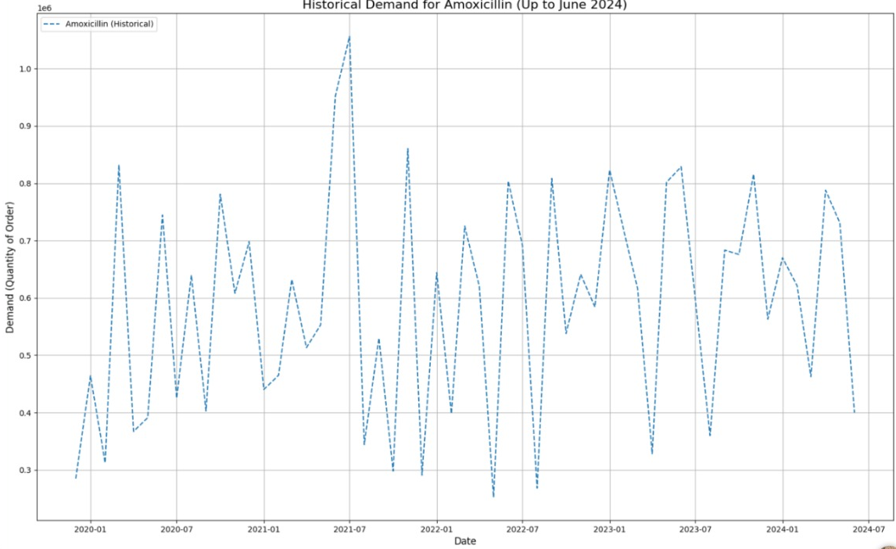
1.1 Historical Demand for Amoxicillin (2020–2024)
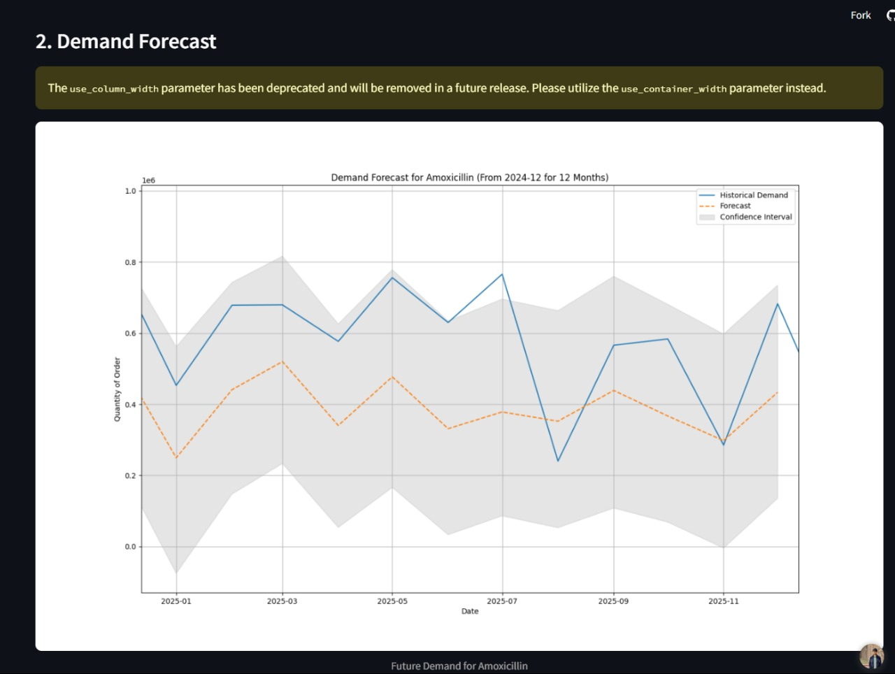
1.2 Forecasted Demand Using Time Series Model (2024–2025)
These figures demonstrate how demand forecasting, when integrated with blockchain transaction data, can enable proactive supply chain decisions and prevent costly disruptions. By capturing real-time insights through on-chain analytics, stakeholders can predict demand fluctuations and act before imbalances occur [6].
Anomaly detection systems are also not being used optimally. Using unsupervised learning techniques such as clustering or isolation forests together with blockchain streams of data would be able to identify fraud and anomalies in real time.
Another area that is not being used is optimization modeling. Techniques like linear programming, genetic algorithms, or reinforcement learning can optimize routes, rest times, and resource allocation to balance cost, speed, and reliability.
From a data architecture point of view, managing vast amounts of heterogeneous, multi-source data is still a challenge. Interoperating blockchain logs, IoT streams, and off-chain databases seamlessly while maintaining standardization, scalability, and privacy is essential.
Lastly, existing systems do not have human-centric visual analytics. More interactive, explainable, and adaptive dashboards driven by natural language generation (NLG) and explainable AI (XAI) are required to facilitate decision-making for various stakeholders.
In conclusion, bringing together blockchain with next-generation data science presents game-changing capability to design better, more durable pharma supply chains.

Proposed Solution: SilkRoad’s MedSafar

With the aim of filling the technological and functional loopholes realized in the literature, SilkRoad presents MedSafar, a dedicated module of its decentralized pharmaceutical supply chain platform. As part of the SIH 2024 program, MedSafar has been designed to provide a complete, scalable, and analytics-based solution that closes the loop in pharma logistics.
MedSafar is end-to-end supply chain traceable, right from raw material purchasing to expired drug safe return and disposal. It facilitates trackable reverse logistics and recall management directly on-chain so that while forward distribution gets tracked, the traceability goes one step forward for post-consumption handling the most left-behind portion of the present-day solutions.
It employs AI-based forecasting and real-time analytics to attempt to address the deficiency of data-driven responsiveness in existing models. It provides dynamic dashboards that reflect trends in understock and overstock, impending expiration of medications, and geographic distribution of supply chain players. Predictive modules enable proactive supply chain decisions by predicting demand surges and informing stakeholders about probable disruptions.
Crossing the limitation of being constrained in the extent of deployment in the real world, MedSafar is implemented via Ethereum smart contracts in Sepolia Testnet and couples IPFS with MongoDB for safe off-chain storage. Hybrid architecture achieves decentralization coupled with scalability through potential integration with national healthcare systems and regulatory APIs.
To meet privacy requirements, the system uses role-based access control (RBAC) to define proper privileges for such participants as raw materials suppliers and healthcare providers to make visibility in data follow participant roles.
Finally, MedSafar prioritizes user accessibility, particularly for small or rural health units. It’'s frontend is built with React and Tailwind CSS for a responsive, user-friendly interface. Supply chain data presented through visual aids like pie charts, bar charts, and real-time maps is easy to understand for all users irrespective of technical orientation.
It is not just a prototype it is a future-proofed template that has been assembled to widen the application of blockchain technology in pharmaceutical SCM by integrating reverse logistics, smart analytics, scalable design, privacy aspects, and accessible design. [5]
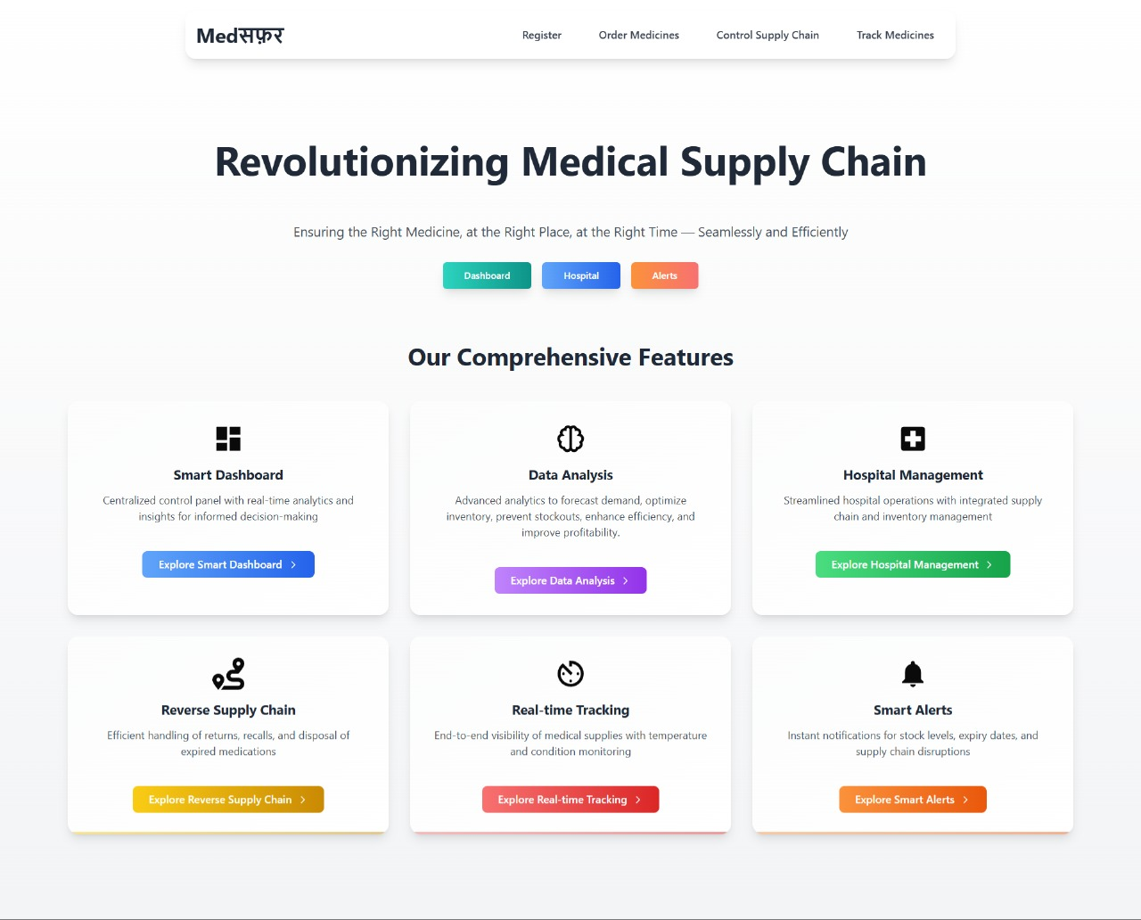
1.3 Silkroad’s MedSafar
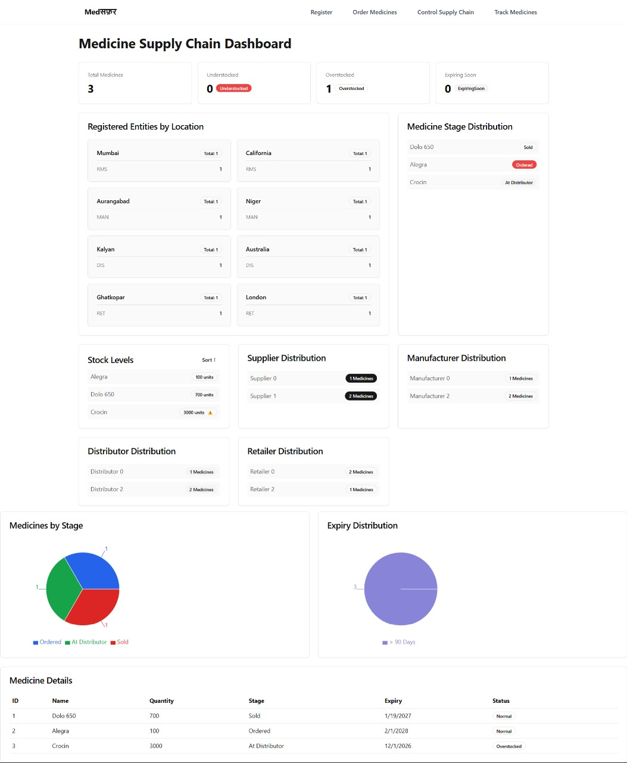
1.4 Medicine Supply Chain Dashboard
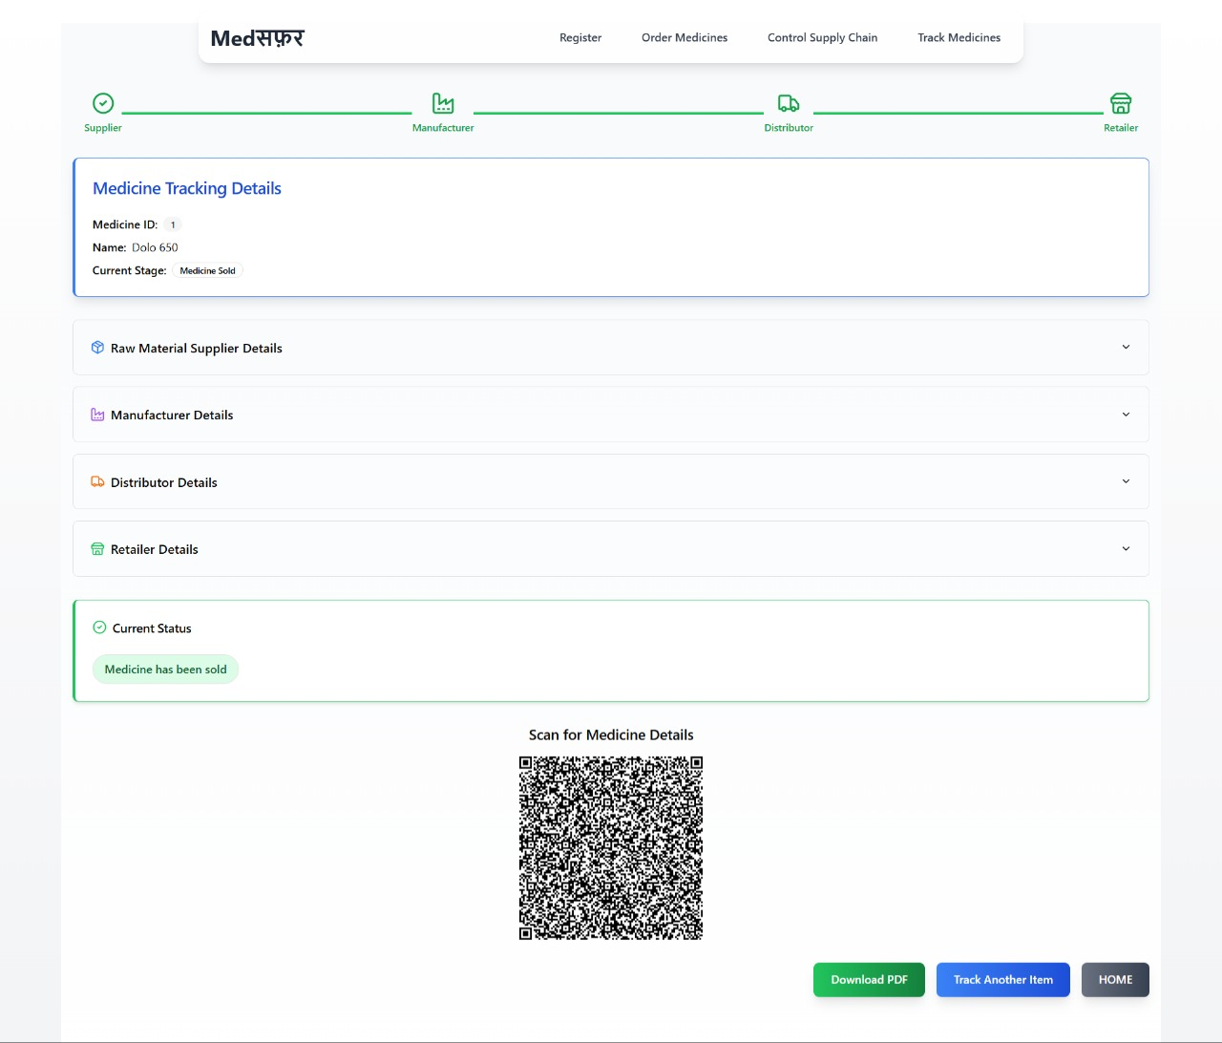
1.5 MedSafar’s Track Medicine Page (Real-Time)

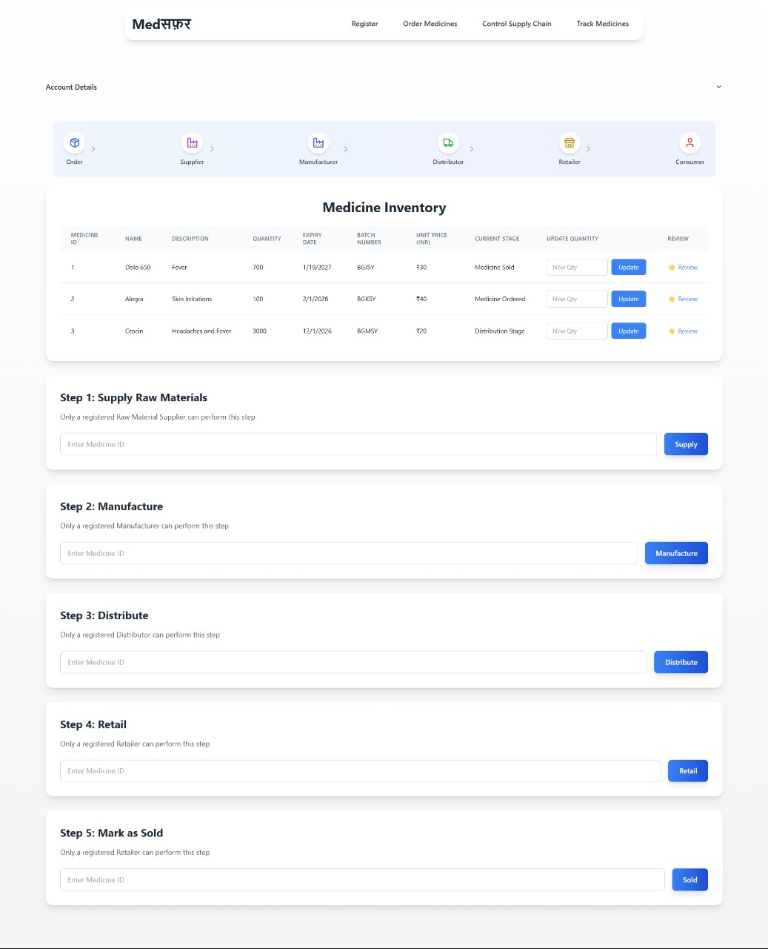
1.6 MedSafar’s Medicine Inventory

Conclusion

Blockchain has shown significant potential in revolutionizing pharmaceutical supply chains by improving transparency, traceability, and operational efficiency. Main features like immutable ledgers, smart contracts, and decentralized data sharing solve the major problems like counterfeit medicines, siloed data, and inefficient recalls. Many studies point to successful implementations:

- Agrawal et al. employed Hyperledger Composer for a secure and effective drug recall system.

- Musamih et al. created an Ethereum-IPFS model for end-to-end traceability of drugs.

- Abdallah and Nizamuddin combined IoT with blockchain for monitoring shipment conditions and preventing fraud.

- Datta and Namasudra emphasized scalability and security through Ethereum and cryptographic methods.

These pieces of work collectively demonstrate blockchain capability to enhance data integrity, reduce intermediaries, and enhance accountability in the pharmaceutical supply chain providing a solid foundation for future convergence with data science methods like predictive analytics, anomaly detection, and optimization modeling to further augment decision-making as well as operational insight. When combined, these technologies enable smarter forecasting, real-time fraud detection, and efficient resource management. This convergence supports a more intelligent, secure, and responsive supply chain, positioning data science as a crucial element in the future of decentralized pharmaceutical systems.

References

[1] Agrawal, D., Minocha, S., Namasudra, S., & Gandomi, A.H. (2023). A Robust Drug Recall Supply Chain Management System using Hyperledger Blockchain Ecosystem. Elsevier.
[2] Musamih, A., Salah, K., Jayaraman, R., Arshad, J., Debe, M., Al-Hammadi, Y., & Ellahham, S. (2023). A Blockchain-Based Approach for Drug Traceability in Healthcare Supply Chain. IEEE Access.
[3] Abdallah, S., & Nizamuddin, N. (2023). Blockchain-based solution for Pharma Supply Chain Industry. Computers & Industrial Engineering, Elsevier.
[4] Datta, S., & Namasudra, S. (2024). Blockchain-based secure and scalable supply chain management system to prevent drug counterfeiting. Springer, Cluster Computing.
[5] SilkRoad Platform
- SilkRoad Official Site: https://silkroad-snzu.vercel.app/
- SIH 2024 Finalist Announcement: https://kjsce.somaiya.edu/en/view-announcement/672/
[6] Drug Supply Chain Analysis and Predictions

List of Figures

Figure 1.1 Historical Demand for Amoxicillin (2020–2024) .............................. 7
Figure 1.2 Forecasted Demand Using Time Series Model (2024–2025) ...................... 7
Figure 1.3 Silkroad’s MedSafar ......................................... 10
Figure 1.4 Medicine Supply Chain Dashboard ......................................... 10
Figure 1.5 MedSafar’s Track Medicine Page (Real-Time) ...................................... 11
Figure 1.6 MedSafar’s Medicine Inventory......................................... 11

List of Tables

Table 1.1 Benefits of Blockchain in SCM ................................................ 3
Table 1.2 Major Supply Chain Challenges & Blockchain Solutions ........................... 5

